A: gProfiler
- Methods
Functional enrichment analysis was performed using g:Profiler on a curated set of 20 human genes representing compensatory antioxidant and Vitamin C transport functions. The gene set included members of the glutathione biosynthesis and recycling pathway (GSS, GCLC, GCLM, GSR, GPX1, GPX4), uric acid and heme metabolism (XDH, UOX, HMOX1), general antioxidant defense (TXNRD1, TXNRD2, TXN, PRDX1, PRDX2, SOD1, SOD2, CAT), and dietary Vitamin C transport (SLC23A1, SLC23A2, CYBRD1). These genes were selected based on their known roles in antioxidant defense and ascorbic acid handling, representing pathways hypothesized to compensate for GULO inactivation. Analysis was performed against the Homo sapiens genome using only annotated genes as the statistical background, with the g:SCS multiple testing correction method. Enrichment was assessed across GO Molecular Function (GO:MF), GO Biological Process (GO:BP), KEGG, and Reactome databases.
- Results
https://biit.cs.ut.ee/gplink/l/a3sCBo4Q4TJ
Enrichment analysis returned 159 statistically significant terms spanning all four databases: 27 GO:MF terms, 104 GO:BP terms, 7 KEGG pathways, and 21 Reactome pathways (first image below). Results organized into three biologically coherent themes.
Antioxidant defense and redox homeostasis dominated the output. The single most significant GO:BP term was response to oxidative stress (GO:0006979, p = 2.870×10⁻²²), driven by 16 of 19 query genes. This was closely followed by cellular oxidant detoxification (p = 1.042×10⁻¹⁸), cell redox homeostasis (p = 1.074×10⁻¹⁴), and cellular response to reactive oxygen species (p = 3.79×10⁻⁶). At the molecular function level, antioxidant activity (GO:0016209, p = 7.707×10⁻²⁰) and oxidoreductase activity (GO:0016491, p = 2.705×10⁻¹⁴) were the top two terms, driven by 11 and 14 genes respectively. In the Reactome database, detoxification of reactive oxygen species (R-HSA-3299685, p = 1.640×10⁻¹⁶) and cellular response to chemical stress (R-HSA-9711123, p = 9.055×10⁻¹⁵) ranked highest.
Glutathione metabolism emerged as the most prominent specific compensatory pathway. Glutathione metabolic process (GO:0006749, p = 2.615×10⁻¹¹) was enriched with 7 genes (GSS, GCLC, GCLM, GSR, GPX1, SOD1, SOD2), and glutathione biosynthetic process (GO:0006750) was separately enriched. In KEGG, glutathione metabolism (KEGG:00480, p = 4.499×10⁻⁸) was the top pathway hit, with 6 genes (GSS, GCLC, GCLM, GSR, GPX1, GPX4). Reactome additionally flagged glutathione synthesis and recycling (R-HSA-174403) and notably a disease pathway — defective GCLC causes hemolytic anemia due to glutathione synthetase deficiency (HAGGSD; R-HSA-5578999) — highlighting the clinical relevance of this compensatory system.
Vitamin C transport and metabolism terms appeared despite Vitamin C biosynthesis genes being absent from the query, confirming that dietary uptake machinery is represented in the compensatory gene set. L-ascorbate sodium symporter activity (GO:0008520) and L-ascorbic acid transmembrane transporter activity (GO:0015229) were both significantly enriched (p = 2.398×10⁻⁴), driven by SLC23A1 and SLC23A2. L-ascorbic acid metabolic process (GO:0019852, p = 3.233×10⁻⁴) and L-ascorbic acid transmembrane transport (GO:0015882, p = 3.314×10⁻³) were enriched at the biological process level. In Reactome, Vitamin C (ascorbate) metabolism (R-HSA-196836, p = 0.022) was also recovered. Notably, FAD binding (GO:0050660, p = 3.372×10⁻⁴) was enriched at the molecular function level — the same FAD-binding domain identified as disrupted in the human GULO pseudogene — suggesting functional overlap between lost and surviving oxidoreductase machinery. Additionally, the NFE2L2/KEAP1 pathway (R-HSA-9755511, p = 9.536×10⁻⁶), a master transcriptional regulator of antioxidant gene expression, was significantly enriched, driven by GCLC, GCLM, HMOX1, TXNRD1, TXN, and PRDX1 — indicating coordinated transcriptional upregulation of the compensatory network.
Full enrichment results across all 159 significant terms are provided in the csv and the other image below.
- Interpretation
The enrichment results reveal that human metabolic adaptation to GULO loss is not mediated by a single compensatory pathway but by a coordinated multi-system antioxidant network. The glutathione system emerges as the primary biochemical substitute, with nearly the entire biosynthetic and recycling cascade (GSS → GCLC/GCLM → GSR → GPX1/GPX4) represented among top hits. The thioredoxin system (TXNRD1/2, TXN, PRDX1/2) provides a parallel redox-balancing mechanism. Together these systems compensate for the loss of ascorbate as a direct electron donor in antioxidant reactions. The strong enrichment of Vitamin C transporter terms (SLC23A1, SLC23A2) is particularly meaningful: since humans cannot synthesize ascorbic acid, selective pressure appears to have preserved and potentially enhanced dietary uptake efficiency. Iron homeostasis terms (multicellular organismal-level iron ion homeostasis, intracellular iron ion homeostasis) are biologically relevant given that Vitamin C normally facilitates dietary iron absorption. Their enrichment suggests compensatory regulation of iron handling following ascorbate loss. The NFE2L2/KEAP1 pathway enrichment indicates that these compensatory responses are transcriptionally coordinated rather than independent, suggesting a systems-level reorganization of oxidative stress response. Finally, the KEGG ferroptosis pathway (p = 7.434×10⁻⁷), driven by GSS, GCLC, GCLM, GPX4, and HMOX1, points to an underappreciated connection between GULO loss and cell death regulation. GPX4 in particular is the primary defender against ferroptotic cell death, a form of oxidative lipid damage that Vitamin C would normally help prevent.

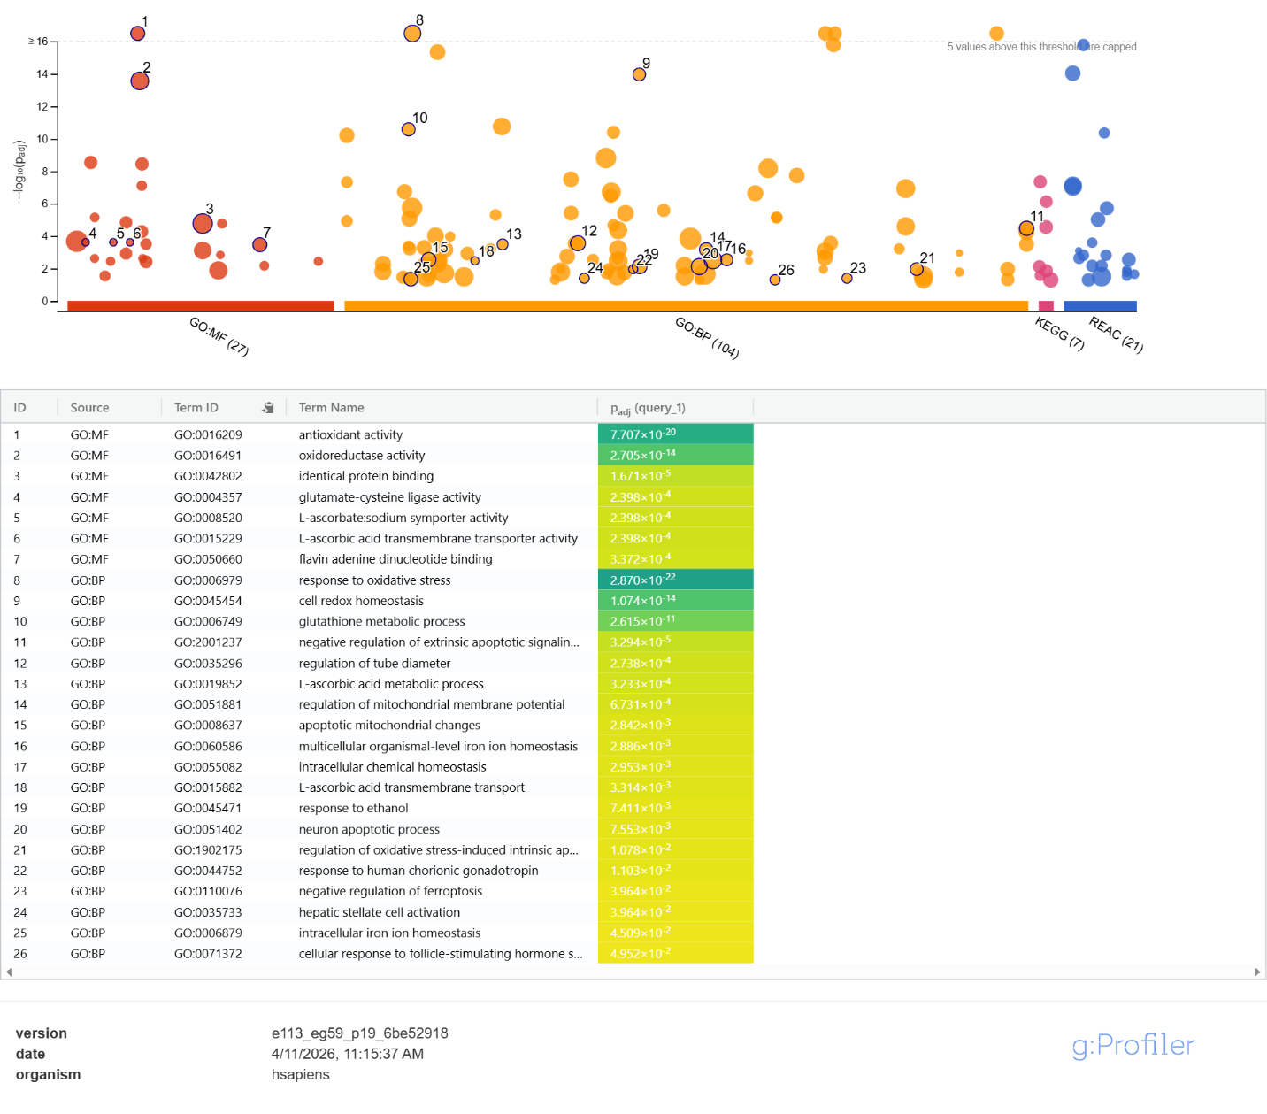Functional enrichment analysis of a 20-gene human compensatory antioxidant gene set performed using g:Profiler (e113_eg59_p19_6be52918). The Manhattan plot displays enriched terms across GO Molecular Function (GO:MF, red), GO Biological Process (GO:BP, orange), KEGG (pink), and Reactome (REAC, blue). Each dot represents one enriched biological term; the y-axis shows −log₁₀ adjusted p-value; dot size reflects the number of query genes annotated to that term. The dashed line indicates the significance threshold. Numbered labels correspond to top enriched terms listed in the accompanying table. Key enriched themes include antioxidant defense, glutathione metabolism, Vitamin C transport, and NFE2L2-mediated transcriptional regulation, collectively reflecting metabolic reorganization following GULO pseudogenization in the human lineage.

B: David
https://davidbioinformatics.nih.gov/chartReport.html?annot=55%2C88%2C10%2C85%2C86%2C91%2C92%2C78%2C27%2C35%2C43%2C90%2C52%2C50%2C65%2C73%2C89
Methods
g:Profiler enrichment results were validated using DAVID Bioinformatics Resources (davidbioinformatics.nih.gov), with the same gene list submitted using OFFICIAL_GENE_SYMBOL identifiers against the Homo sapiens background, and functional annotation charts generated across GO Biological Process, GO Molecular Function, and KEGG pathway categories.
g:Profiler Results Validation
DAVID enrichment analysis corroborated all major findings from g:Profiler. The top enriched biological process was again response to oxidative stress (p = 1.33×10⁻²⁴, 14 of 19 genes), followed by cell redox homeostasis (p = 5.60×10⁻¹⁵, fold enrichment = 186.72) and glutathione metabolic process (p = 8.33×10⁻¹⁰, fold enrichment = 120.82). At the molecular function level, oxidoreductase activity (p = 1.90×10⁻¹⁴, 13 genes) and antioxidant activity were highly enriched. KEGG analysis confirmed glutathione metabolism (p = 3.23×10⁻⁸) and ferroptosis (p = 5.79×10⁻⁷) as the top pathways. Notably, L-ascorbic acid metabolic process (p = 4.40×10⁻⁵), L-ascorbate sodium symporter activity (p = 1.87×10⁻³), and L-ascorbic acid transmembrane transport (p = 2.77×10⁻³) were all significantly enriched, directly confirming the role of dietary Vitamin C uptake machinery as a compensatory adaptation. FAD binding was enriched in both tools, and DAVID additionally flagged flavin adenine dinucleotide binding (p = 3.16×10⁻⁵) driven by TXNRD1, TXNRD2, GSR, and XDH — all oxidoreductases that functionally overlap with the lost GULO enzyme. The consistent agreement between g:Profiler and DAVID across all major themes (antioxidant defense, glutathione metabolism, and Vitamin C transport) strengthens confidence in the biological interpretation.
Extra Finding
DAVID additionally identified hereditary hemolytic anemia as a significantly enriched disease term, driven by glutathione pathway genes GCLC, GSS, and GSR, highlighting that deficiencies in the compensatory antioxidant network have direct clinical consequences, consistent with the known pathological effects of severe Vitamin C deficiency on red blood cell integrity.

